Continuous Integration with Jenkins

1. Create a security group which allows ssh from local, and allows on port 8080

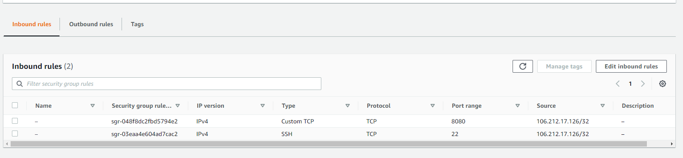And create access key for login EC2 instance.

1. Create a EC2 instance with the below user data,

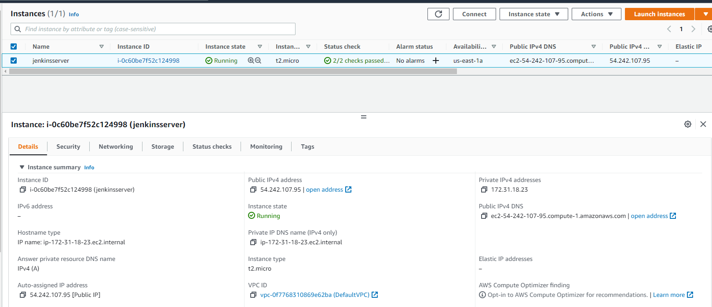

**#!/bin/bash**

**sudo apt update**

**sudo apt install openjdk-11-jdk -y**

**curl -fsSL https://pkg.jenkins.io/debian-stable/jenkins.io.key | sudo tee \**

**/usr/share/keyrings/jenkins-keyring.asc > /dev/null**

**echo deb [signed-by=/usr/share/keyrings/jenkins-keyring.asc] \**

**https://pkg.jenkins.io/debian-stable binary/ | sudo tee \**

**/etc/apt/sources.list.d/jenkins.list > /dev/null**

**sudo apt-get update**

**sudo apt-get install jenkins –y**

1. We can see jenkins running on th e port 8080,

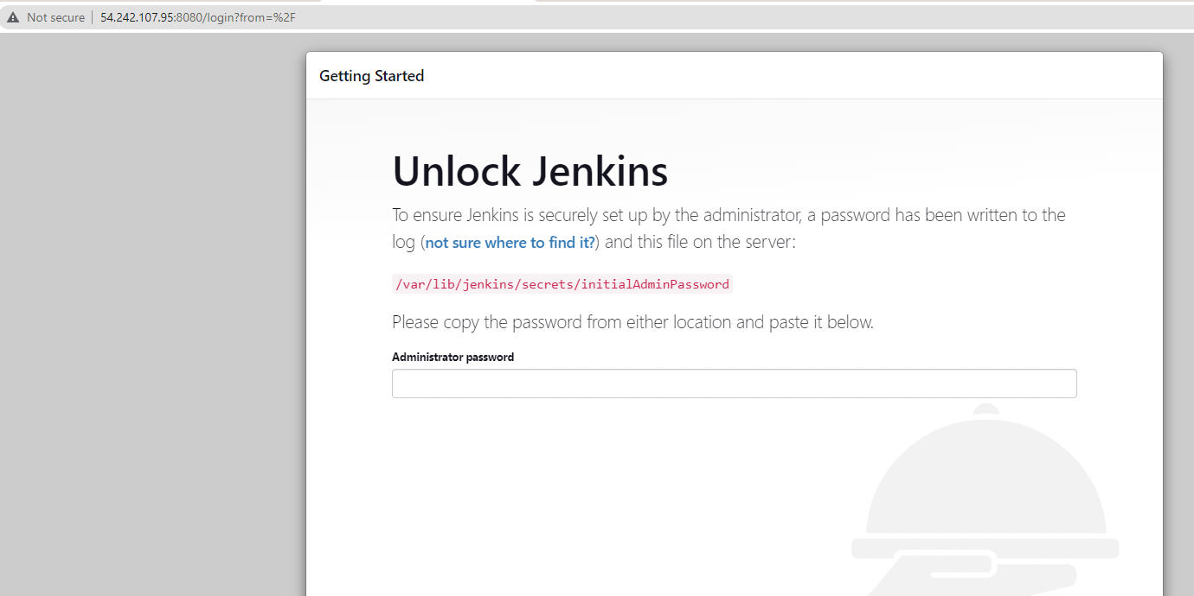

1. Connect to Jenkins server from local bash using the key.

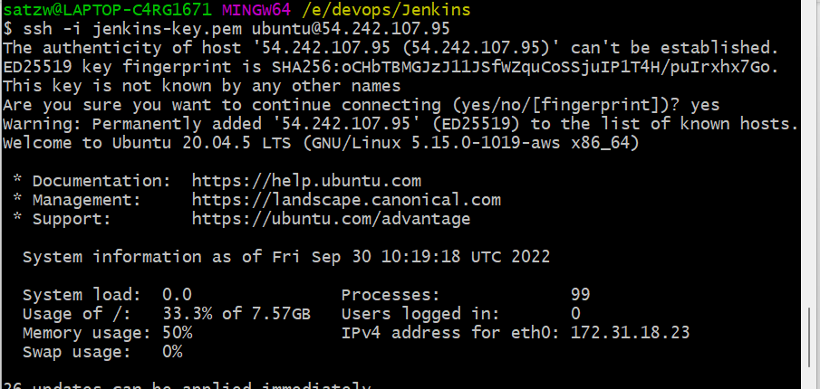

1. Check jenkins is running,

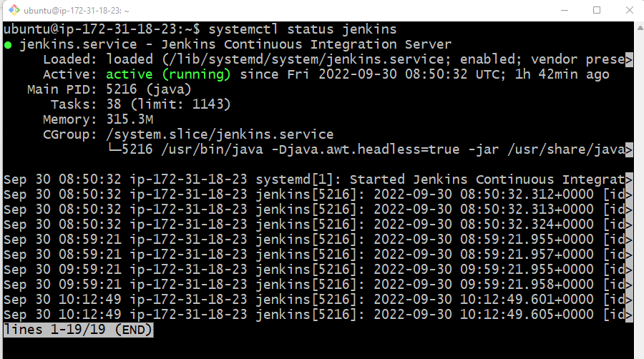

1. Get the jenkins password from cat/var/lib/jenkins/secrets/initialAdminPassword



With pwd login to the jenkins portal.

1. Update global tool configuration,
   1. Create a oracle account
   2. Select jdk8u221 and choose oracle account
   3. Select Maven 3.8.6

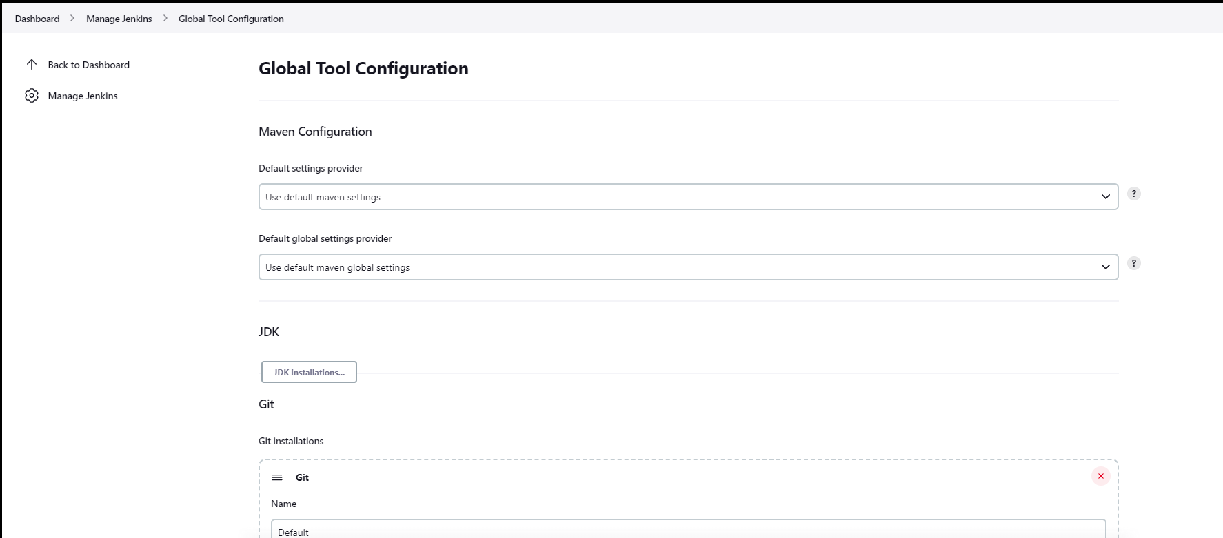

1. Create a new job, in a freestyle project
   1. Choose git <https://github.com/satzwebio/vprofile-repo.git>

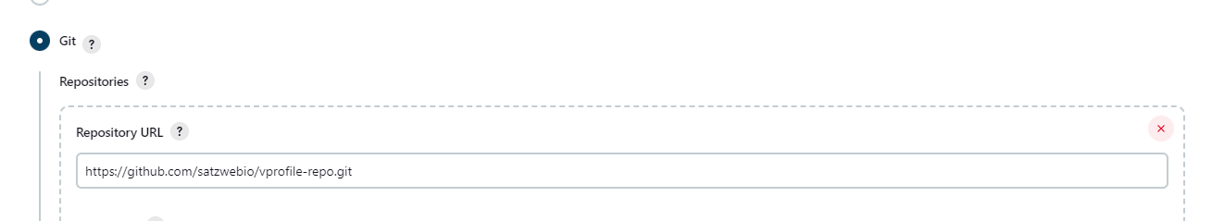

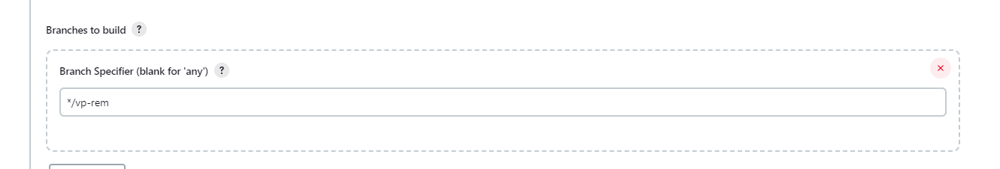

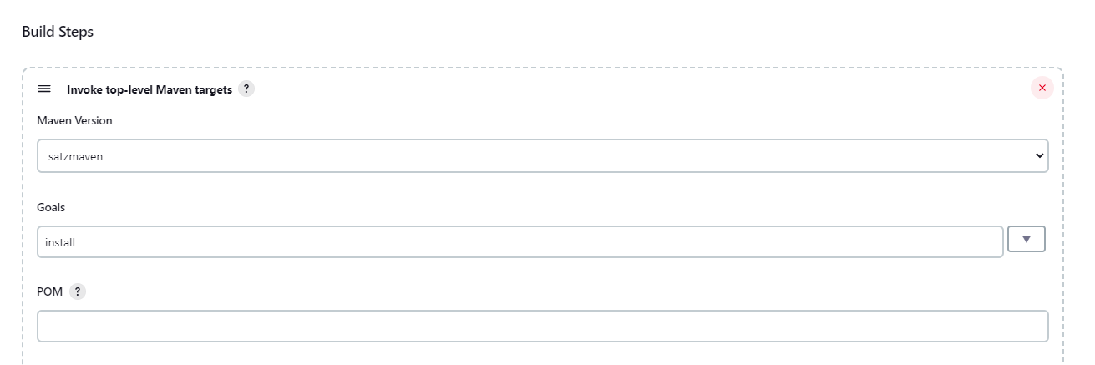

Click on Buildnow to build the job and

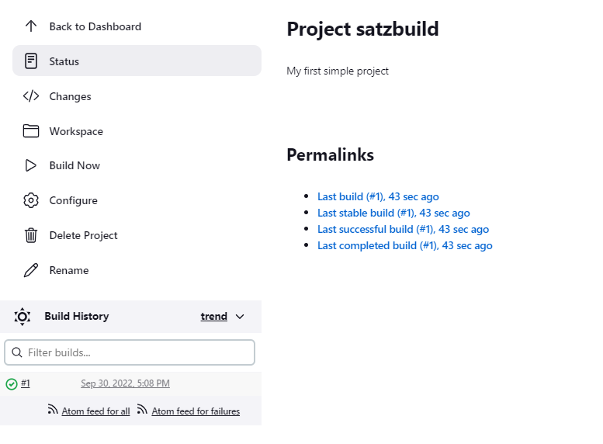

Console will show build is successfully completed

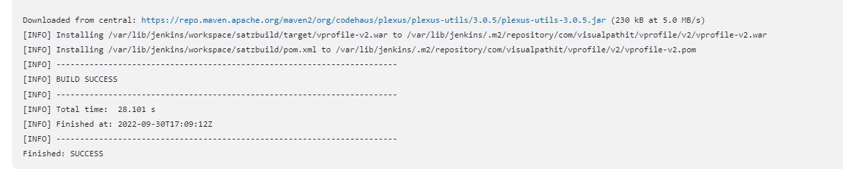

1. Workspace will show the files the job generated.

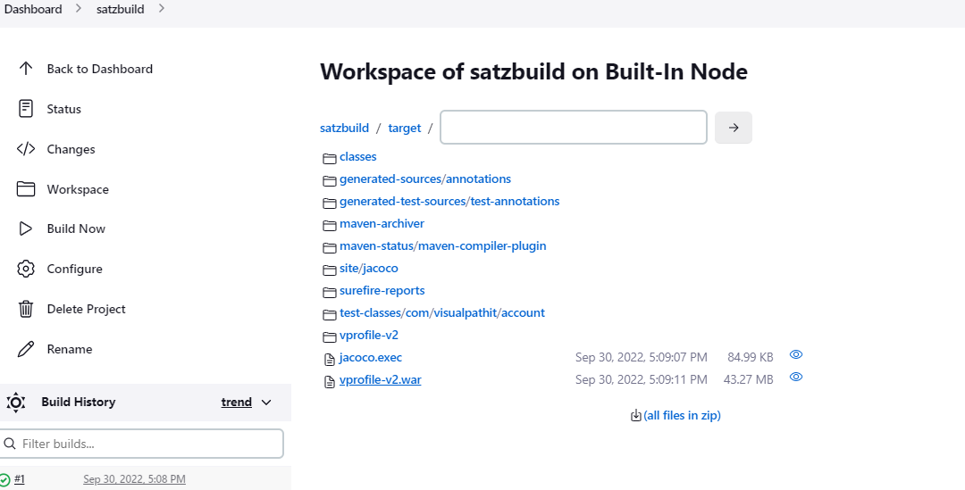

1. To archive the file that ends with .war inside any directory archive it. It in post build section.

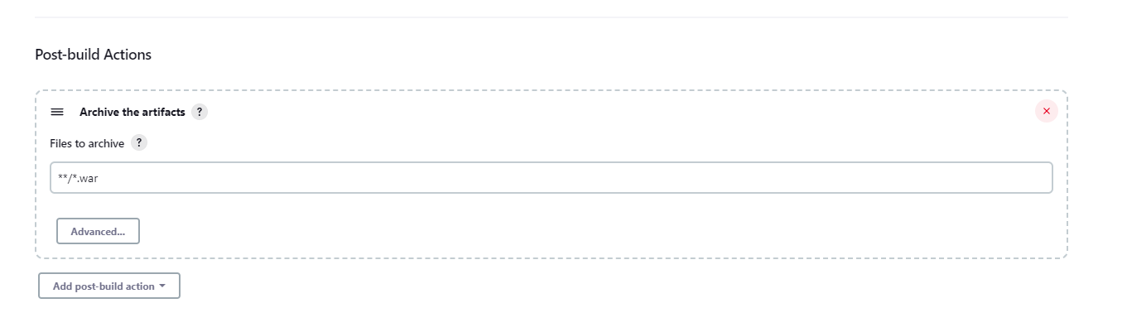

After build last successful artifacts will be archived,

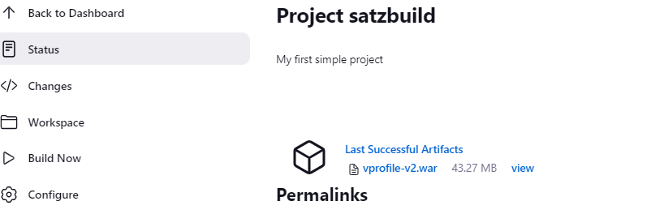

To move the artifacts into a new directory, with a new filename every time. Add this in build step

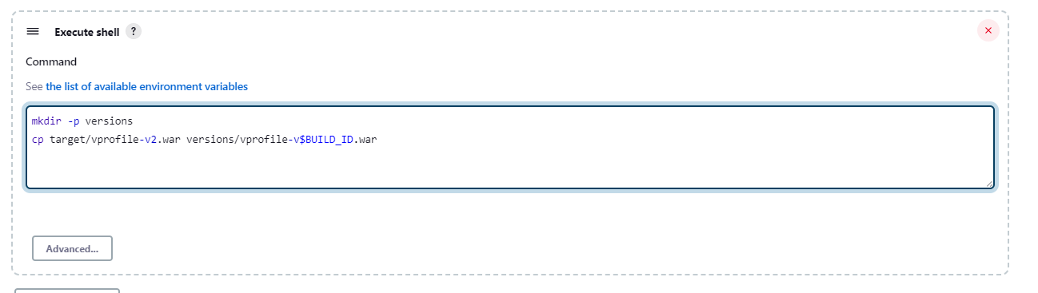

1. The below option enable user to enter build the value with parameter. Create a variable like “VERSION”, then in build step use $VERSION

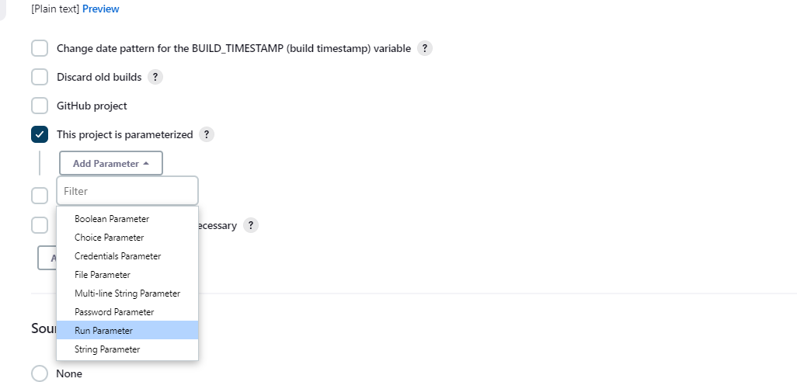

Or you can select change date pattern and enter pattern below and use $BUILD_TIMESTAMP in execute shell.

